Conversion of RS232 to RS485

1.0 General Information

This solution uses a microcontroller bridge which will convert the RS 232 to RS485 (MODBUS) signal. The controller takes the RS232 signal as input buffer and make a packet to send it to the slave device. This solution works as a bridge between PLC and RS485 slave devices

2.0 Prerequisite

1. [ESP32 Wroom](https://robocraze.com/products/esp32-development-board?currency=INR&variant=40193649803417&utm_medium=cpc&utm_source=google&utm_campaign=Google%20Shopping&https://robocraze.com/?utm_source=googleads&utm_medium=ppc&gclid=CjwKCAjw3K2XBhAzEiwAmmgrAploT9SWsnZKvCAea3be-OmbUzDr1uTIaaGpFkWkJrrFXSefFRGHEhoCVOYQAvD_BwE)

# [DB-9 RS232 to TTL Converter](https://robocraze.com/products/db-9-rs232-to-ttl-converter?currency=INR&variant=40192593330329&utm_medium=cpc&utm_source=google&utm_campaign=Google%20Shopping&https://robocraze.com/?utm_source=googleads&utm_medium=ppc&gclid=Cj0KCQjwuaiXBhCCARIsAKZLt3nQ6VWsyEdCa9KhYqQMa_xOGPWAs5873wN-PaID3fkUBRoYR3zacL0aAl38EALw_wcB)

1. [MAX-485 TTL to RS-485 Converter Module](https://robocraze.com/products/max485-rs-485-module-ttl-module?currency=INR&variant=40192907346073&utm_medium=cpc&utm_source=google&utm_campaign=Google%20Shopping&https://robocraze.com/?utm_source=googleads&utm_medium=ppc&gclid=CjwKCAjw3K2XBhAzEiwAmmgrAtD1NTg65cKCpPcCaOysO4C5E2pSJN-q46NV6XHALSIS9O_x1fQyURoCb5YQAvD_BwE)
2. Male Jumper wires
3. Casing(Breadboard for testing)

3.0 Working

The ESP32 has two UART communication ports. On one port, we connect DB-9 RS232 converter and receive data and on the second UART port we connect MAX-485 TTL to RS485 Converter module to send and receive data.

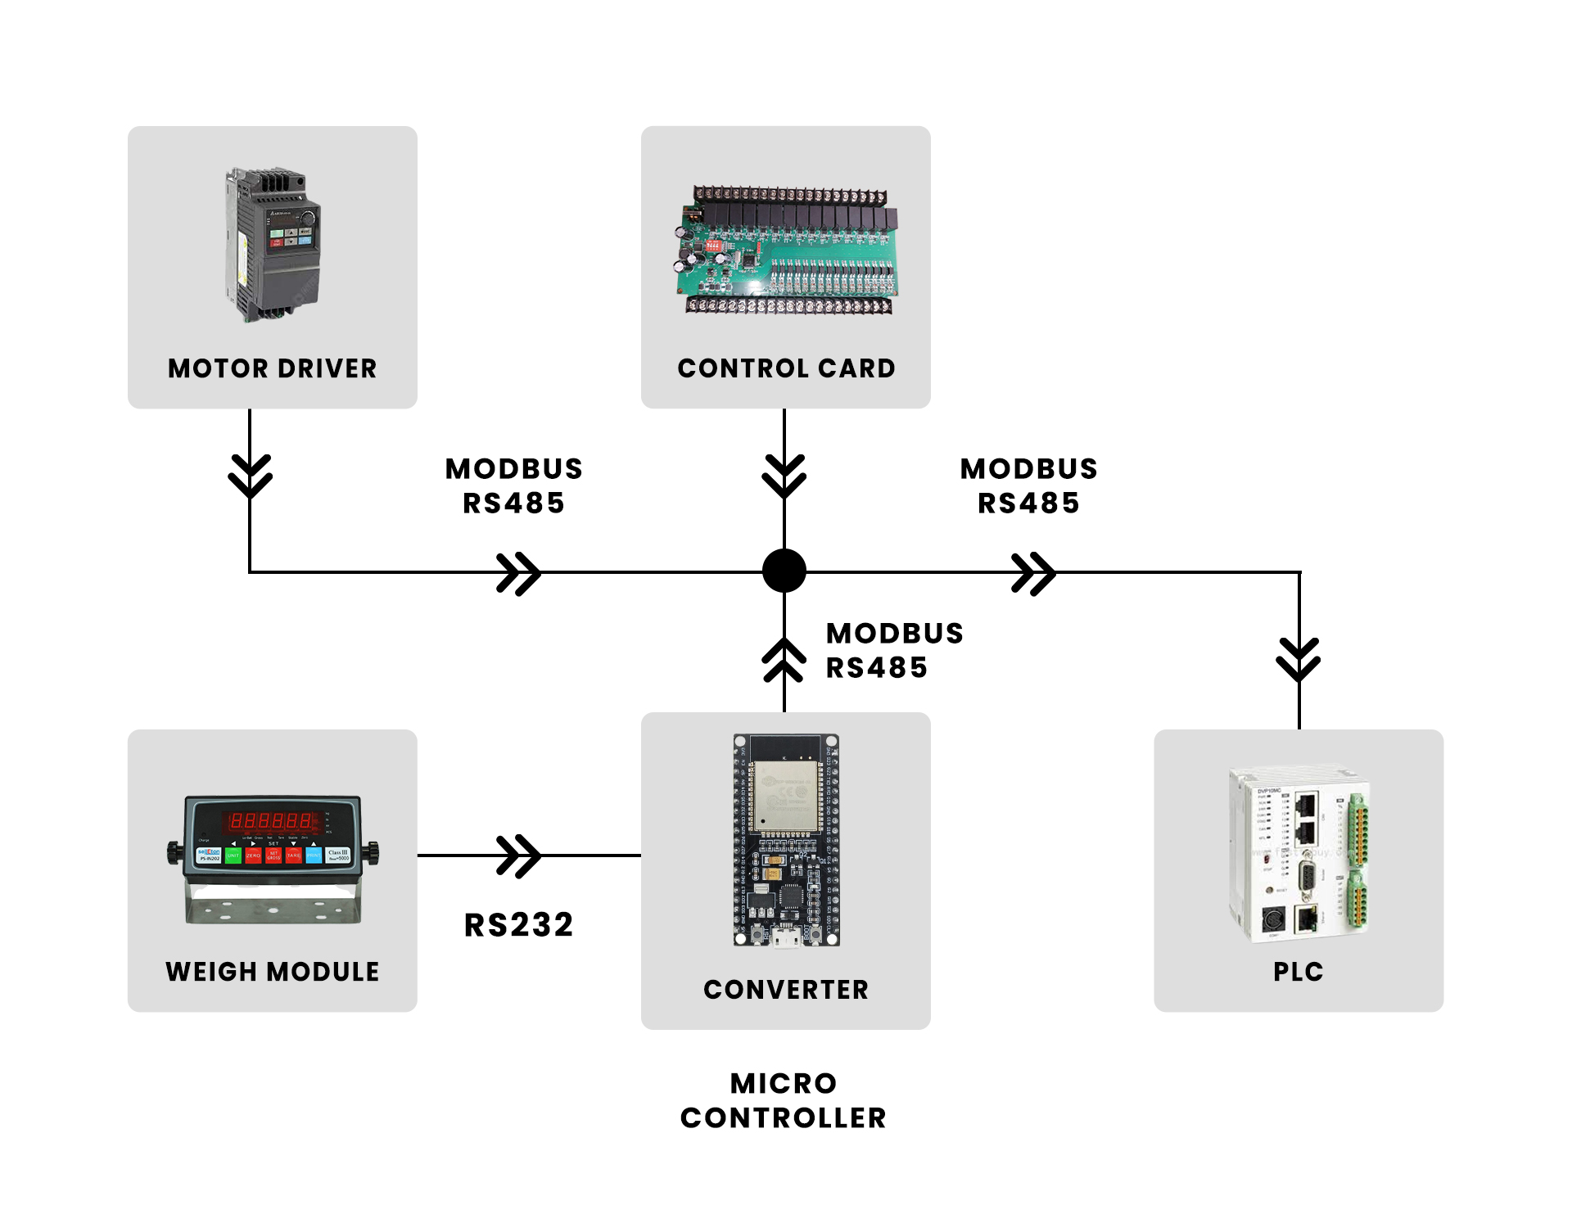

**Wire Connections**

Connections of RS232 module to ESP32 board

**RS232**  **ESP32**

Vcc Vin

RXD 16

TXD 17

GND GND

Connections of Max485 module to ESP32 board

**RS485**  **ESP32**

Vcc Vin

GND GND

RE 32

DE 33

RX 26

TX 27

**Installation Of Arduino IDE**

Prefer to download the arduino IDE from the [link](https://www.arduino.cc/en/donate/) and install the application.

The modbus code for the esp32 is provided and you need to configure the port and Board etc.

1. Open the Arduino IDE and go to File>Preferences and in the Additional boards Manager URL paste the url <https://raw.githubusercontent.com/espressif/arduino-esp32/gh-pages/package_esp32_index.json>
2. Open the Boards Manager. Go to **Tools** > **Board** > **Boards Manager**

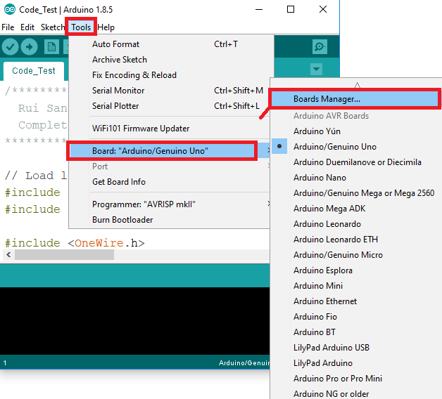

If it is downloaded then select the option mentioned in the screenshot.

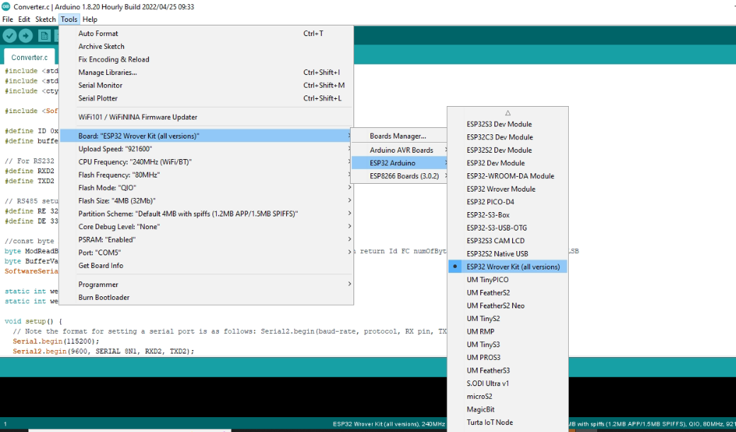

1. We are using the [ESPSoftwareSerial](https://www.arduino.cc/reference/en/libraries/espsoftwareserial/) Library to read the Modbus RTU RS485 Data on serial port.
2. After completing these steps select the com port on which you have connected the esp32 USB

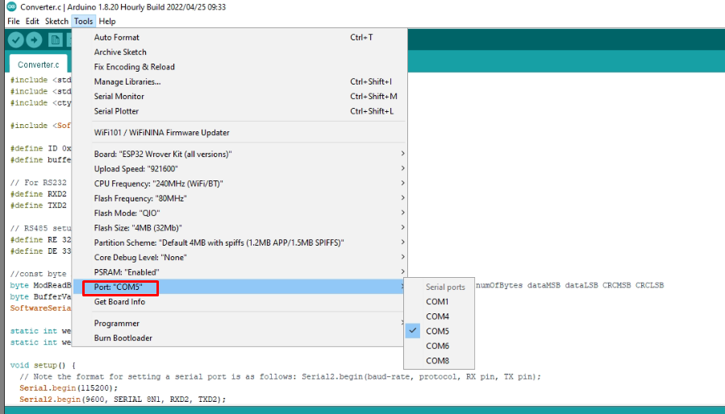

1. Now upload the code by clicking on the arrow button.

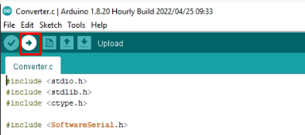

1. Hold the BOOT button on the ESP32 board while clicking on the Upload button on Arduino IDE.Once it identifies the chip, you can release the BOOT button and the code will be uploaded. To reset the microcontroller, press the EN button once.
2. The message will be shown like this after the successful upload and press the EN button after it.

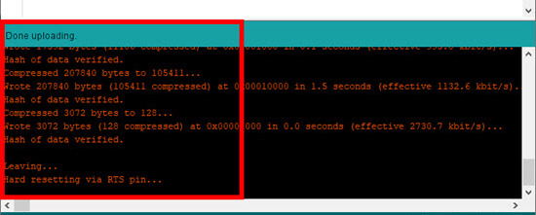

1. In case you want to change the ID of the controller, you need to change the hex value of the ID and upload it.

